Coupling between tectonics, climate and sediment supply in Okavango delta.

Report of GPS Survey of October 2010

Participants:
O. Dauteuil (Géosciences Rennes, UR1), F. Moreau (Géosciences Rennes, UR1)
P. Wolski (ORI, UB), Mosai (ORI, UB)

Date: from 4 October 2010 to 15 October 2010
Project topics:
The Okavango Delta is the second largest inland delta in the world. Currently the Okavango is a endoreic system in which each year about 11,000 km3 of water irrigates 15,000 km2 of desert increasing the water level of 2-4 m. Water coming from Angola is purified in the delta as it passes through a complex system of aquifers and of many sandy islands where it evaporates leaving huge quantities of salt. The delta is located in a depression controlled by a set of faults trending north-east south-west forming a graben that limited its south-east extend. These faults are active and a balance seems exist between the tectonic subsidence and the sediment filling of the delta. This project was devoted to two aspects:
1: current deformation of the graben from a network of GPS receivers and a field mapping of faults.
2: fluvial sedimentary system and the Okavango (impact deformation and climate) with a characterization of sedimentary facies over time and track conditions.
The project is a partnership between Okavango Research Institute (University of Botswana) and Géosciences Rennes (university of Rennes 1)

Aims of the 2010 survey:
The topics of this field trip was see how to install a temporary GPS network around the Okavango delta. The setup of this network was done to record the ground deformation induced by water loading, sediment loading and extensional deformation. The station will form the Okavango GPS Array (OGAr)
GPS Network
Three kinds of receivers were used during this survey:
- Maun station : TRIMBLE NETRS belonging to ORI/HOORC. Its is a permanent station installed since September 2010 integrated in the Africa Array GPS Network.
- Nxara station: TRIMBLE 4700 installed during this field trip in Nxara HOORC camp. This station is installed permanently.
6 GPS receivers TOPCON GB1000 borrowed by INSU-CNRS (National French institute of Universe Sciences). They were used as temporary stations. 9 temporary stations were installed (see map for locations)
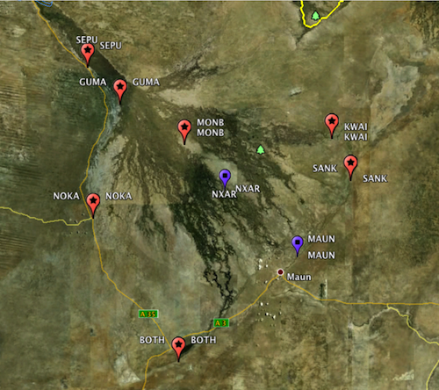
Figure 1: GoogleEarth map with stations of Okavango GPS Array

Figure 1: GoogleEarth map with stations of Okavango GPS Array
For further informations about each station and site, see log sheets included at the end of the report.
The combination of the different sites allows getting two one permanent array (P-OGAr) and one temporary array (T-OGAr):
- Permanent Okavango GPS Array (P-OGAr) with stations MAUN and NXAR. This permanent array can record the daily variations of the ground deformation, especially the effect of water loading.
- Temporary Okavango GPS Array (T-OGAr) with stations MOMB, SANK, KWAI, BOTH, NOKA, SEPU, GUMA. The network is powerful to access to annual spatial deformation induced by water and tectonics. The setup allows the mapping of displacement along and perpendicular to the delta. To be efficient, it should be measured at least four times per year.
To sum up the settlement of the GPS stations was a complete success and the array of sites should be answer to the topics of the project.

Technical and logistic aspects.
The successful of the survey was largely due to the ORI logistic support for the car, the camp equipment and several things. It is also mainly due to the participation of Mosai as a driver and especially for the talks with the school manager where the GPS were installed.

